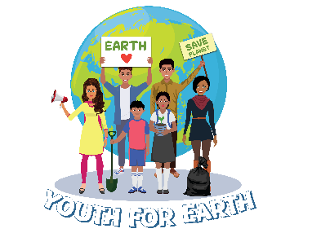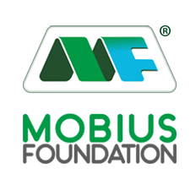

**Youth For Earth 2025**

**Frequently Asked Questions (FAQs)**

**Application Related**

**Q 1: Can school students apply in the senior category?**

**Ans:** No, school students must apply under the junior category, while college/university students are eligible for the senior category. Applications submitted in the incorrect category will not be accepted.

**Q 2: Can I apply individually for this program, without registering through a school or college?  
Ans:** No, individual applications will not be considered. Only groups of students registered through their respective schools or colleges will be eligible to participate in this program.

**Q 3: Can we apply as a group of students without a teacher as a mentor, with one student acting as the leader for the program?**

**Ans:** No, it is mandatory to have a teacher or faculty member involved as a mentor to guide the group. This ensures proper supervision and support throughout the program. Additionally, all official communication will be conducted through the assigned mentor, who is designated by the principal or director of the school/college.

**Q 4: Can we opt for a topic not mentioned in the provided list of sub-themes for the project?**

**Ans.** Yes, if your topic aligns with this year's Youth for Earth theme, you may proceed with it. The topic should fall under the broader scope of innovation and solutions for the growth of Green Jobs.

**Q 5: Can we include the ongoing projects of the schools/colleges for this program? Will they be considered valid?**

**Ans:** Yes, ongoing projects can be submitted for the campaign, provided they were initiated after October 2024. You will need to submit geotagged pictures and a journey video from October 2024 onwards. These materials must be included in the project report submission for the project.

**Q 6: Can we submit a model-based project with theoretical research only, without on-ground application?**

**Ans:** No, the project submission must include both theoretical research and practical aspects. It should demonstrate a practical approach with field implementation and showcase innovative solutions. The combination of research and real-world application is essential to ensure the project's relevance and impact.

**Q 7: How many team members can be there for a project?**

**Ans:** Each project team should consist of a minimum of 5 members and a maximum of 8 members. Additionally, one teacher or faculty member must act as the mentor for the team.

**Q 8: Can one school/college submit two or more projects?**

**Ans:** Yes, if the school or college has multiple branches, each branch can submit one project. However, a maximum of two projects will be accepted from a single school or college, and they must focus on different sub-themes. Submissions exceeding this limit or not adhering to the sub-theme requirement will not be entertained.

**Project Report Submission Related**

**Q 1: What are the prescribed specifications for uploading reports, pictures, and videos?**

**Ans:** Submit the report in the provided format, ensuring all sections are properly filled. All images must be high resolution & geotagged to confirm the location of the project. The 1-minute video should document the start-to-end journey of the project, and it must be in MP4 format. *\*Click here to download Project Submission format*

**Q 2: Can we submit videos in the local language?**

**Ans:** Yes, you can submit videos in your local language. However, to ensure broader understanding, you must include English subtitles. This will help make your content accessible to a wider audience, including those who may not understand the local language.

**Q 3: Where can I contact if I have doubts regarding project submission?**

**Ans:** Please ensure you follow the guidelines and meet the deadlines provided in our email communications. If you have any questions or need further clarification, feel free to reach out to us at: youthforearth.y4e@gmail.com. We are here to help!

**Certificates & Prize Money Disbursement Related**

**Q1: Do participating students and mentors receive a certificate of participation?**  
**Ans:** Yes, all participating students will receive a certificate of participation upon completing the report submission process. Additionally, mentors will be awarded a certificate of mentorship for their valuable contribution to the program.

**Q2: Do we get a certificate at the ICSE 2025?**  
**Ans:** Certificates will be awarded as follows:

* Winning teams and their mentors will receive certificates at the event.
* Non-winning team members who complete the report submission process will receive their certificates via email. Mentors will be responsible for distributing these certificates to their respective team members.

**Q3: How and when will we receive the prize money after winning?**  
**Ans:**

* The prize money will be transferred directly to the official bank account of the respective school or college.
* The transfer will be initiated once the Youth for Earth team receives the required testimonials and supporting documentation from the winning school/college.
* No payments will be made to the personal accounts of mentors or students.
* The prize money disbursement process will begin 15 days after the event.

**Q4: What happens if a team fails to submit the required documentation or testimonial videos?**  
**Ans:** The disbursement of prize money will be delayed if the required documentation and testimonials are not submitted within the specified timeline.

**Q5: Is there any specific format for the testimonial videos and documentation?**  
**Ans:** Yes, a detailed guideline for the testimonial video format and required documents will be provided to the winning teams after the event through their institution’s official email address for further communication.